**Documentation For Graduate Admission Analysis & Prediction**

**Project Title:** Graduate Admission Analysis & Prediction

**Team ID:** Team_4331

**Team Leader Name:** Dev Ashvinbhai Patel

|  |
| --- |
| Kirtan Nileshbhai Tank |
| Anup Rajeshbhai Tailor |
| Jeel Vireshbhai Patel |

**Team Member Names:**

**Team Leader Email :** devpl1412@gmail.com

**Institute Name :** R.N.G. Patel Institute Of Technology

**Abstract:**

Graduate admission analysis and prediction is a critical task for universities and colleges as they strive to maintain the quality of their graduate programs and increase enrollment. This analysis involves examining a wide range of factors, including applicant demographics, academic background, standardized test scores, letters of recommendation, personal statements, and work experience.

One of the primary objectives of graduate admission analysis and prediction is to identify the factors that are most predictive of graduate school success. By analyzing data on previous cohorts of students, universities can identify the factors that are most strongly associated with positive academic outcomes, such as high GPAs, successful completion of research projects, and job placement after graduation. These factors can then be used to create a predictive model that can be applied to new cohorts of students to determine their likelihood of success in the graduate program.

Another important aspect of graduate admission analysis and prediction is identifying areas where universities can improve their recruitment efforts. By analyzing the characteristics of successful applicants, universities can identify which types of students are most likely to succeed in their programs and tailor their recruitment efforts accordingly. This can include targeting students from certain geographic regions, undergraduate institutions, or academic backgrounds, as well as developing marketing campaigns that highlight the unique strengths and opportunities offered by the graduate program.

Overall, graduate admission analysis and prediction plays a critical role in helping universities maintain the quality of their graduate programs, increase enrollment, and attract the best and brightest students. By leveraging data and analytics to identify the factors that are most predictive of success and tailoring their recruitment efforts accordingly, universities can continue to attract and retain top talent and ensure the ongoing success of their graduate programs.

**Introduction:**

Graduate school admission is a rigorous process that involves assessing applicants based on their academic background, standardized test scores, letters of recommendation, personal statements, and work experience. Universities and colleges need to analyze a wide range of data to determine the factors that are most predictive of success in their graduate programs. Graduate admission analysis and prediction is a crucial task for institutions, as it helps them maintain the quality of their graduate programs, increase enrollment, and attract the best students.

One of the primary objectives of graduate admission analysis and prediction is to identify the factors that are most predictive of success in the program. This involves analyzing data from previous cohorts of students to determine which factors are most strongly associated with positive academic outcomes, such as high GPAs, successful completion of research projects, and job placement after graduation. By identifying these factors, universities can create predictive models that can be applied to new cohorts of students to determine their likelihood of success in the program.

Another important aspect of graduate admission analysis and prediction is identifying areas where universities can improve their recruitment efforts. By analyzing the characteristics of successful applicants, universities can identify which types of students are most likely to succeed in their programs and tailor their recruitment efforts accordingly. This can include targeting students from certain geographic regions, undergraduate institutions, or academic backgrounds, as well as developing marketing campaigns that highlight the unique strengths and opportunities offered by the graduate program.

Universities can also use graduate admission analysis and prediction to evaluate the effectiveness of their admission criteria and make adjustments as needed. For example, if the analysis shows that certain criteria are not strongly predictive of success in the program, universities can adjust their admission criteria to focus more on the factors that are most strongly associated with positive outcomes.

In addition, graduate admission analysis and prediction can help universities identify areas where they can provide additional support to students to increase their likelihood of success in the program. For example, if the analysis shows that students from certain academic backgrounds are less likely to succeed in the program, universities can provide additional support in the form of tutoring, mentoring, or other resources to help these students succeed.

In conclusion, graduate admission analysis and prediction is a critical task for universities and colleges as they strive to maintain the quality of their graduate programs, increase enrollment, and attract the best students. By analyzing data on previous cohorts of students, universities can identify the factors that are most predictive of success, tailor their recruitment efforts, evaluate their admission criteria, and provide additional support to students as needed. This data-driven approach to graduate admission can help universities attract and retain top talent and ensure the ongoing success of their graduate programs.

**Block Diagram:**

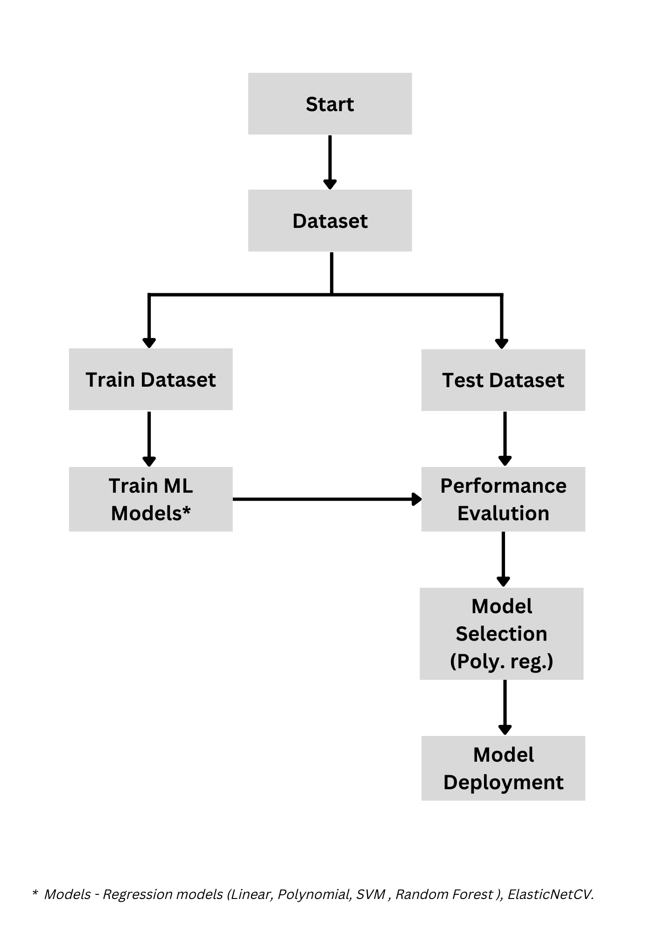

**Technologies:**

**Dataset:** [Graduate Admission 2 | Kaggle](https://www.kaggle.com/datasets/mohansacharya/graduate-admissions)

**Programming language:** Python

**Platform :** 1.  Google colab

2. Jupyter Notebook

3. Github

4, Streamlit

5. Kaggle

**Results:**

* We have done the comparative analysis on the different model such as Multiple Linear Regression, Polynomial Regression, Elastic net Regression, Random Forest Regression and SVM Regression.
* 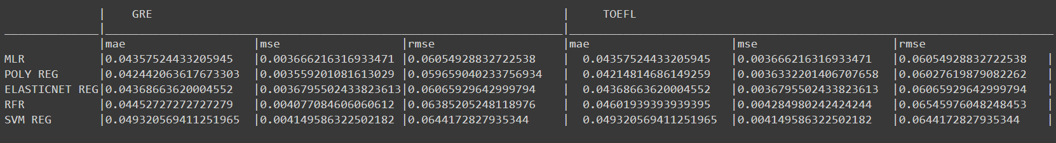Below snip show the mean absolute error, mean square error and root mean square error on two different parameters GRE and TOEFL. In which the Polynomial Regression use to be perform little bit more efficiently than the other model given below.
* Our model predict accurately over the different parameter and inputs of the users.
* Overall, the result of a graduate admission analysis and prediction project is a valuable resource for students, educators, and institutions alike, helping to improve the college application process and increase access to higher education opportunities.
* The following videolink is the illustration how our website works:-
  + **Video Link :** [Admission_predictor_video_illustration.mp4](https://drive.google.com/file/d/1ZHqxIzYib2Krspxkuo3HcxOeP8X-vedr/view)
  + **Github Link :** [Graduate-Admission-Analysis-and-Prediction](https://github.com/DevPatel1412/Graduate-Admission-Analysis-and-Prediction)
* The following is a link for our web application hosted on Streamlit Cloud is given below : -
  + **Web Application:** [Streamlit](https://devpatel1412-graduate-admission-anal-admission-predictor-nb0j80.streamlit.app/)

**Conclusion:**

In conclusion, both students and universities can benefit from the Graduate Admission Analysis and Prediction tool. Universities can determine the likelihood of a student's acceptance and make well-informed choices by assessing a variety of indicators, including academic achievement, test scores, and personal statements. Students can benefit from this study by receiving insightful input on their strengths and weaknesses, which will help them choose where to apply.

Furthermore, this study can assist institutions in identifying flaws in their admissions procedure, such prejudice or the requirement for more varied selection criteria. It is crucial to remember, nevertheless, that while this research might offer insightful information, admissions choices shouldn't solely be based on it. To ensure a varied and well-rounded student body, an all-encompassing approach to admissions is required, taking into account aspects other than academic performance.

To ensure a varied and well-rounded student body, an all-encompassing approach to admissions is required, taking into account aspects other than academic performance.

Overall, the Graduate Admission Analysis and Prediction is a helpful tool for universities and applicants alike, offering insightful information and assisting in making well-informed choices during the admissions process.

**Future Scope:**

The future scope for Graduate Admission Analysis and Prediction is promising, as there is a growing need for universities to make data-driven decisions in their admissions process. With advances in technology and data analytics, it is likely that more sophisticated algorithms and models will be developed to better predict a student's likelihood of acceptance.

Following are the future scope of this project:-

* In machine learning the model works more efficiently and give better performance with the more and more data you feed to it. So, in future dataset range can be extended.for example, we can extend the dataset for IELTS, GMAT, SAT, ACT etc.
* we can have more useful recommendation such as the likelihood of student in which specific university and the country
* Deep Neural Networks will be used as yet another reasonable model to comprehend the arbitrary character of admission.

**Reference:**

* Dataset: [Graduate Admission 2 | Kaggle](https://www.kaggle.com/datasets/mohansacharya/graduate-admissions)
* Research Paper: [(PDF) A Comparison of Regression Models for Prediction of Graduate Admissions (researchgate.net)](https://www.researchgate.net/publication/336436894_A_Comparison_of_Regression_Models_for_Prediction_of_Graduate_Admissions)